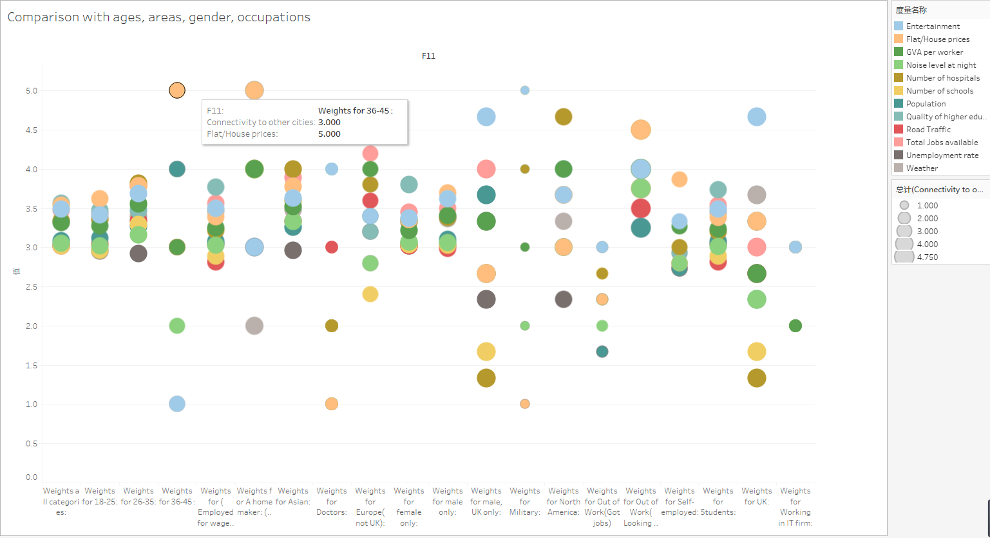

Figure 1 The comparison from the survey

As we can see from above picture, we take the survey result as the source data and transform it as a visualization picture. There are 121 people take part in the survey, the research is based on that. According to related investigation we consider there are about thirteen parameters will affect one’s ideal living cities when move to a new place, there are Flat or House price, population, Road traffic, GVA per worker, Unemployment rate, Noise rate at night, Total jobs available, Weather, Numbers of schools, Entertainment, Quality of high education, Numbers of hospital, Connectivity to other cities.

To find the details related to specific crowd, we divided this people into different groups through four different kinds factors.

First, for the people of different ages, the same factor will make different effect on them. For example, the weather will be a most important factor to the elderly, but the for the young it won’t be the most important reason for them, even it will become a simple problem when compare to flat price and entertainment. As we can see within the figure one, people age from 18 to 45 all think the flat or house price as the most important factor when move to a new city, in contrast to this, these young and middle-aged people will not pay too much attention to the unemployment rate. With ages change, the flat price will become more and more important. For the young the weight of house price is about 3.6 but for the people between 36 to 45 is almost 5.

Secondly, we try to find if the region makes senses to these factors. We got response from different area, the result was divided into four different regions, Asian, Europe region but not in UK, UK and North America. As we can see people from Asian is more concentrated, these people take almost all factors within a small range from 3 to 4, but as usually they consider unemployment rate as slight important reasons at all, the numbers of hospital become the most important reasons. However, when it comes to the UK local people, the average weight for the numbers of hospital is just about 1.33 which is a thought-provoking question, the local people will take entertainment as their main problem when move to a new city, this factor got average 4.67 points. For people from EU, these guys also consider the house price is the most important reason among the whole factors, but they don’t think numbers of schools is a very important reason. For the people form North America are also take numbers of hospital as the most important factor, but the unemployment is the least important factor. Third, we split the people by gender, in terms of female, the connectivity is the most important reason but for the male the flat price is still the main problem, the connectivity is just the second important reason which is also make sense.

Last, we do statistical Analysis by occupations, which is the most interesting part the occupation quite does affect. For example, the homemaker will think the flat price as the most important factor of all, they don’t care about the weather which is just weighted about 2 points. Besides this, for students, the quality of education is the biggest influencing factors of all, the road traffic and other almost will not affect their choice. But for others occupation don’t have some specific features when move to new cities.